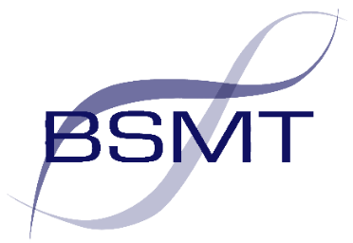

BRITISH SOCIETY FOR MICROBIAL TECHNOLOGY

38th ANNUAL MICROBIOLOGY CONFERENCE
Royal Air Force Museum, Hendon
Date: Thursday 11th May 2023

Current Topics in Microbiology and Infection

08.30 – 09.55 | Registration, Coffee and Trade Show
09.55 – 10.15 | Formal hand over of Chair of BSMT: Dr Valerie Bevan  Welcome to Conference and Overview of the Day by BSMT Chair: Dr Mark Wilks
 | Chair for the Morning Session: Professor Brian Duerden CBE
10.15 – 10.55 | Overview of the development of AMR and approaches to controlling it  Professor Alasdair MacGowan, Professor of Antimicrobial Therapeutics, University of Bristol
10.55 – 11.30 | How the diagnostic laboratory detects AMR  Dr Mandy Wootton, Scientific Lead, Specialist Antimicrobial Chemotherapy Unit, Public Heath Wales, Cardiff
11.30 – 12.00 | Break & Trade Show (with light refreshments)
12.00 – 12.35 | Advances in NGS for the detection of AMR and their use in diagnostics and IPC  Dr Nathanial Storey, Senior Bioinformatician, Department of Bioinformatics, Great Ormond Street Hospital, London
12.35 – 13.10 | Laboratory development for AMR surveillance in low- and middle-income countries  Dr Claire Gordon, Consultant in Infection, Rare & Imported Pathogens Laboratory (RIPL) UK Health Security Agency, London
13.10 – 14.30 | Trade Show & Lunch
 | Chair for the Afternoon Session: Dr Kate Templeton
14.30 – 15.05 | Network-wide analysis of the Serosep EntericBio Gastro Panel 2 and C. difficile assays for the detection of enteric pathogens in Public Health Wales microbiology laboratories  Michael Perry, Lead Clinical Scientist, Molecular Diagnostic Unit, Public Health Wales, Cardiff
15.05 – 15.40 | Advantages and disadvantages of molecular methods over culture in the detection of orthopaedic infections  Dr Kevin Cole, Senior BMS, North Tyneside General Hospital, Newcastle
15.40 – 16.15 | Group A streptococcal infections and other infections in children in the post-pandemic period  Dr Charlene Rodrigues, Consultant in Paediatric Infectious Diseases, St Mary's Hospital, London and London School of Hygiene & Tropical Medicine
Cost: Early Bird Discount of £95:00 applies to registrations received before 16 April 2023 (Extended date)
The higher rate of £110:00 will apply to registrations received after this date
Full Time Student Rate £45
(Fee includes morning coffee, light refreshments & lunch)

Applications may be submitted: 1) Register for the conference here
2) on-line via the link on the BSMT website: www.bsmt.org.uk
3) via the link in a BSMT email received
@Micro_bsmt
Follow us
Please note that photos may be taken throughout the day for BSMT publicity

