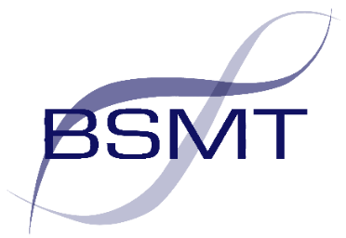

BSMT 38th Annual Microbiology Conference
11th May 2023
Current Topics in Microbiology and Infection

Speaker profiles

Professor Alisdair MacGowan

Consultant in Infection at North Bristol NHS Trust & Professor of Antimicrobial Therapeutics at the University of Bristol

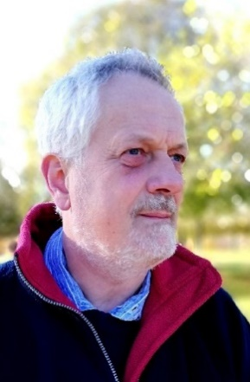
Professor Alasdair MacGowan is Consultant in Infection at North Bristol NHS Trust and Professor of Antimicrobial Therapeutics at the University of Bristol. He has led research groups in the area of antimicrobial chemotherapy for over twenty-five years, and also provides medical input into the National Antibiotic Assay Reference Laboratory at Southmead Hospital. He has a research interest in antibacterial pharmacokinetics/dynamics, rapid diagnostics, antimicrobial resistance in the community and also encouraging patient and public involvement in infection research. He currently holds several Programme Grants related to antibacterial drug development and was microbiological lead on a joint MRC (UK) China project studying antimicrobial resistance in rural China. He is a former President of the British Society for Antimicrobial Chemotherapy (BSAC), is a member of the BSAC Standing Committee on Antimicrobial Susceptibility Testing and is UK representative on European CDC Expert Committee EUCAST. He is a Fellow of both the Royal College of Physicians (Edinburgh) and the Royal College of Pathologists and was a first title bearer of Fellowship of ESCMID.

Professor MacGowan will give an overview on the current situation regarding the development of antimicrobial resistance and discuss potential approaches to controlling this.

Dr Mandy Wootton

Consultant Scientist/Operational Manager, Specialist Antimicrobial Chemotherapy Unit (SACU), Public Health Wales
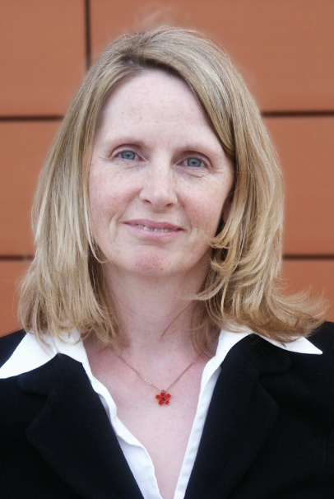
Dr Wootton is currently Consultant Scientist/Operational manager of the Specialist Antimicrobial Chemotherapy Unit (SACU) in Public Health Wales, a unit providing an antibiotic resistance reference service to Wales. She has over20 years’ experience of susceptibility testing methods and resistance mechanisms. She is secretary of the BSAC susceptibility testing committee, providing educational workshops and conferences plus is an active participant in developing EUCAST methodology and guidelines for the European Development Laboratory (EDL). Prior to Cardiff she spent over 10 years in clinical research on antibiotics in Bristol, where she completed her PhD in glycopeptide resistance in S. aureus.
Dr Wootton is therefore well placed to provide an update on susceptibility testing methods at the BSMT conference.

Dr Nathaniel Storey

Bioinformatician, Great Ormond Street Hospital for Children NHS Foundation Trust
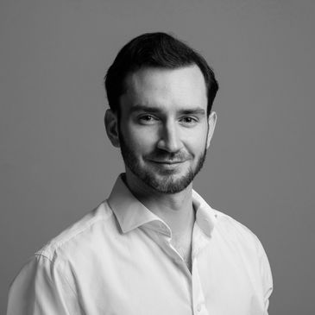
Dr Nathaniel Storey is a bioinformatician and molecular biologist involved in the design and deployment of NGS solutions within healthcare. His current research involves the use of new and emerging sequencing technologies to support rapid diagnostics alongside bioinformatic tools for clinical data analysis with a focus on sepsis, SARS-CoV-2 and antimicrobial resistance.
As lead investigator for the GOSH arm of the SEPTIMET study Dr Storey has been involved in the development of rapid diagnostic pathways for the investigation of sepsis using nanopore sequencing technology
Dr Storey will be talking on the use of rapid sequencing techniques for the detection and assessment of AMR and how this might apply to areas such as typing and infection control.

Dr Claire Gordon

Consultant in Infectious Diseases and Deputy head of the UKHSA Rare and Imported Pathogens Laboratory
Dr Claire Gordon is a consultant in Infectious Diseases and Clinical Microbiology and is deputy unit head of the UKHSA Rare and Imported Pathogens Laboratory. Her early medical training was in Northern Ireland, before higher specialty training in ID/microbiology in London and then Oxford, where she also completed a DPhil in the use of Whole Genome Sequencing for investigating disease due to Staphylococcus aureus. Following completion of training she worked at the KEMRI-Wellcome Trust Research Programme in Kenya. In 2018 she moved back from Kenya to take up the post of lead clinical microbiologist for the UK Department of Health Fleming Fund programme, which supports development of AMR surveillance in low- and middle-income countries. She moved from the Fleming Fund to UKHSA in 2020.

Michael Perry

Deputy Lead Clinical Scientist at the UK anaerobe reference laboratory
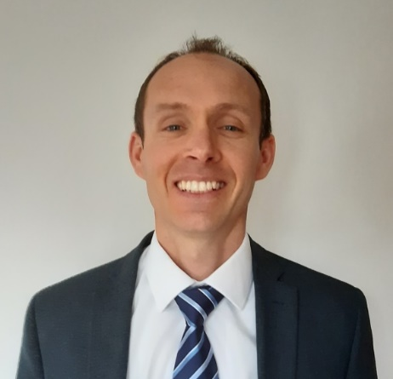
Michael is a registered Clinical Scientist and Higher Specialist Scientist Trainee in microbiology as well as the deputy lead scientist for the UK Anaerobe Reference Unit, based at Public Health Wales in Cardiff.

He has led on the service evaluation, development and implementation of many nucleic acid amplification methods for screening, primary detection and confirmation of infectious disease. In 2018, Michael was the Lead Scientist for Public Health Wales in the successful implementation of molecular enteric assays for routine detection of infectious intestinal disease across a country-wide laboratory network.

His main area of research and development is currently the use of molecular methods and whole genome sequencing (WGS) for anaerobic bacteria to improve diagnostic speed and accuracy and to allow for effective patient management, outbreak investigation and prevention and control of infection. He was instrumental in the successful introduction of Clostridioides difficile WGS for routine typing for patients with C. difficile infection (CDI) in Wales.

Michael is the chair of the Wales C. difficile Infection Focus Forum, which he established in 2021 in response to increasing rates of CDI within Wales, and across the UK. The forum is multidisciplinary in nature and has links with colleagues across the UK and Ireland.

Dr Kevin Cole

Senior Biomedical Scientist, North Tyneside General Hospital.
Kevin started as a trainee Biomedical Scientist in medical microbiology at North Tyneside General Hospital. He also spent eight years working for Public Health England in Brighton where he did a PhD in whole-genome sequencing of S. epidermidis in orthopaedic device-related infections. He is now back at North Tyneside as a Senior Biomedical Scientist in molecular microbiology.

Dr Charlene Rodrigues

Consultant in Paediatric infectious disease at Imperial college healthcare trust
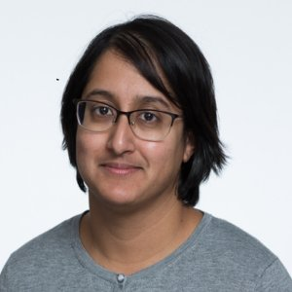
Dr Charlene Rodrigues is a paediatric consultant specialising in infectious diseases at St Mary's Hospital, London. She also undertakes research in microbial genomics with the London School of Hygiene and Tropical Medicine.
After graduating from medical school at Leicester University in 2007 Charlene subsequently trained as an NIHR Academic Clinical Fellow (Imperial College London). She completed Paediatric Infectious Diseases/Immunology GRID training (Great North Children's Hospital, Newcastle) with Microbiology (St George's Hospital, London). She has long been interested in genomics, in the context of host and pathogen variation, and undertook a Wellcome Trust funded DPhil in genomic epidemiology (University of Oxford), studying meningococcal vaccine antigens.
Charlene is working to better integrate genomics and bioinformatic analyses into healthcare settings to ensure they are more accessible to clinicians, microbiologists and epidemiologists to improve patient care. She will be presenting on the topic of Group A Streptococci in children and how this may be changing after the SARS-Cov-2 pandemic

